**Practical No.10**

**Aim: Web Browser Forensics**

**-Web Browser working**

**-Forensics activities on browser**

**-Cache / Cookies analysis**

**-Last Internet activity**

**Steps: 1. Open BrowserHistoryExaminer.**

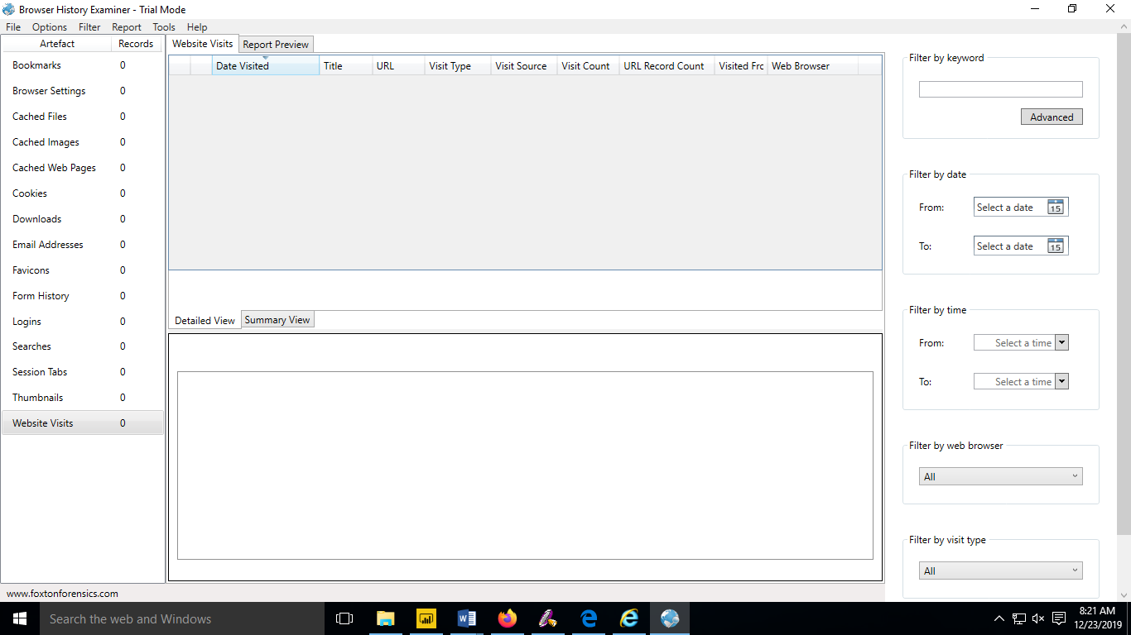

**2. Click on file > Capture History.**

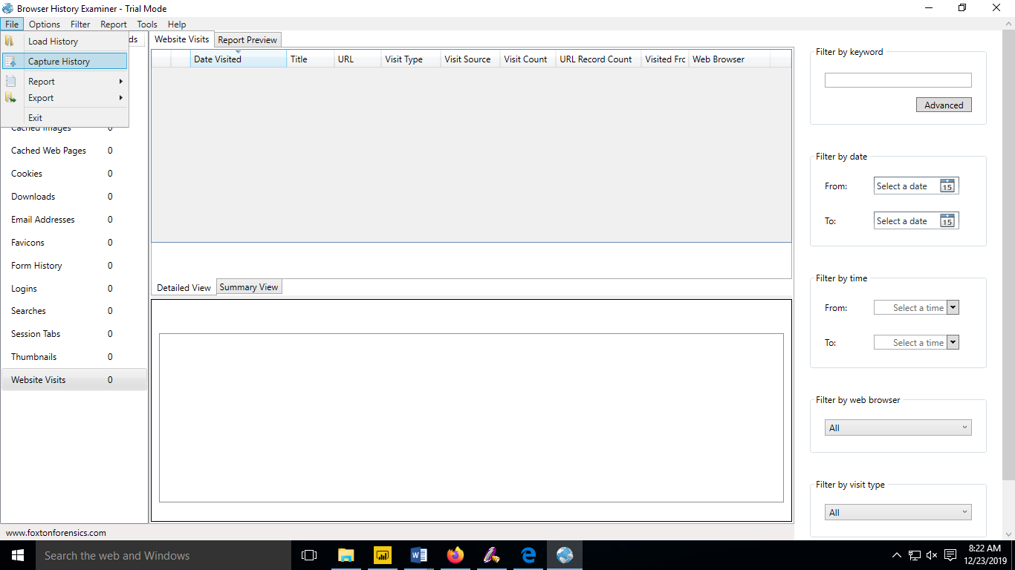

**3. Select the capture folder and click on next.**

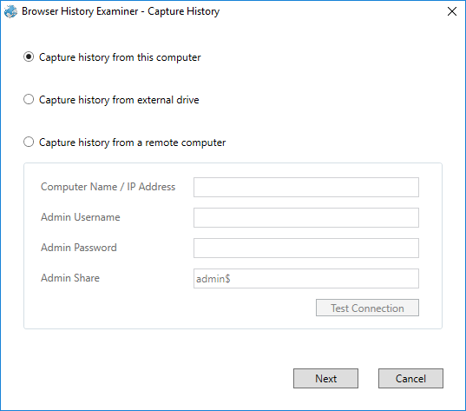

**4. Enter the destination to capture the data.**

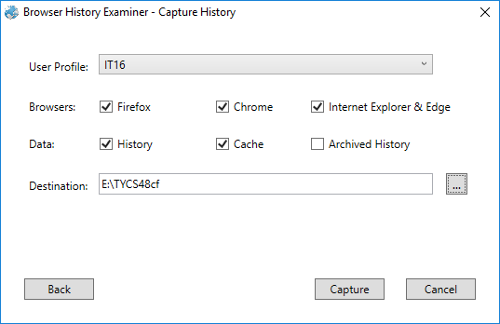

**5. The History is been extracting.**

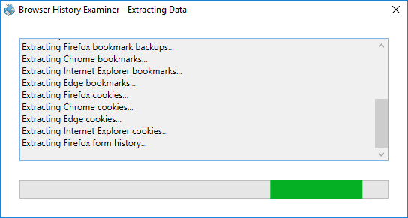

**6. The data has been retrieved.**

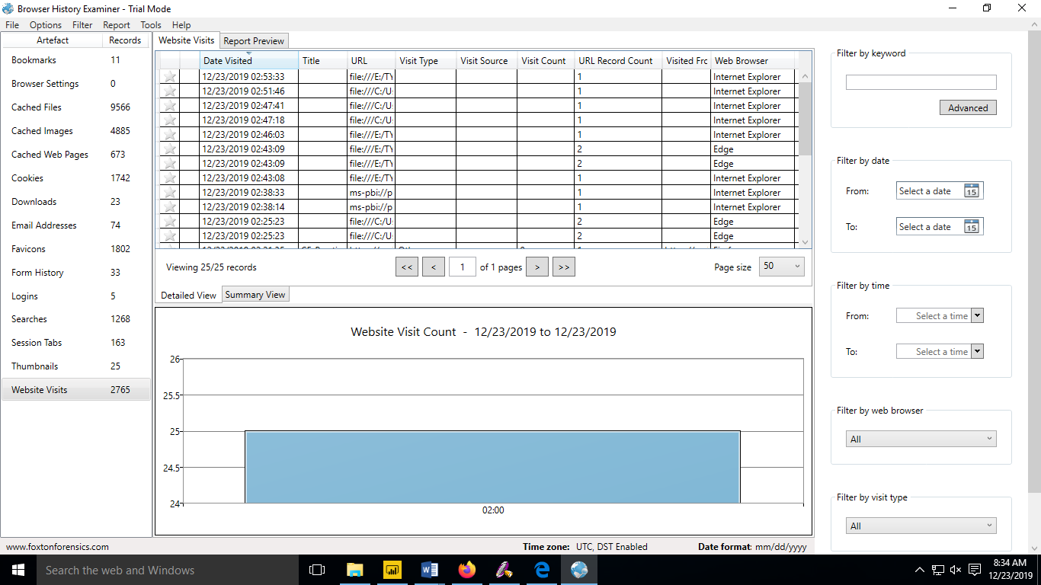

**7. On the left panel click on bookmarks**

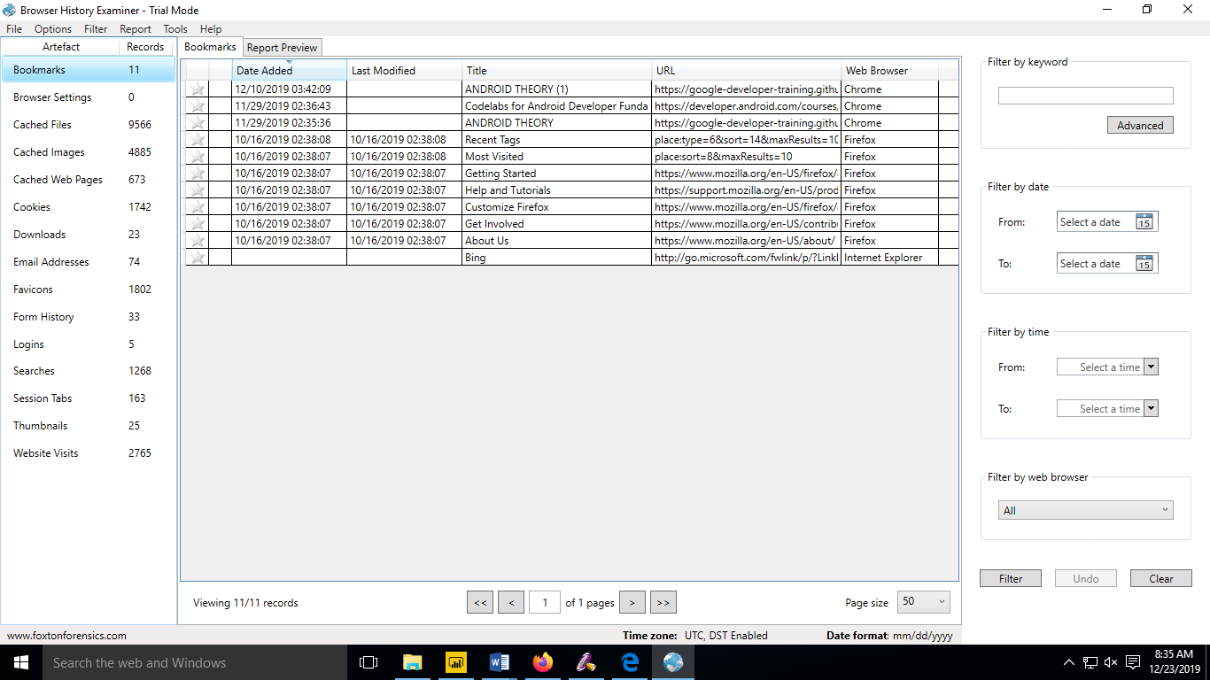

**8. On the left panel click on cached files.**

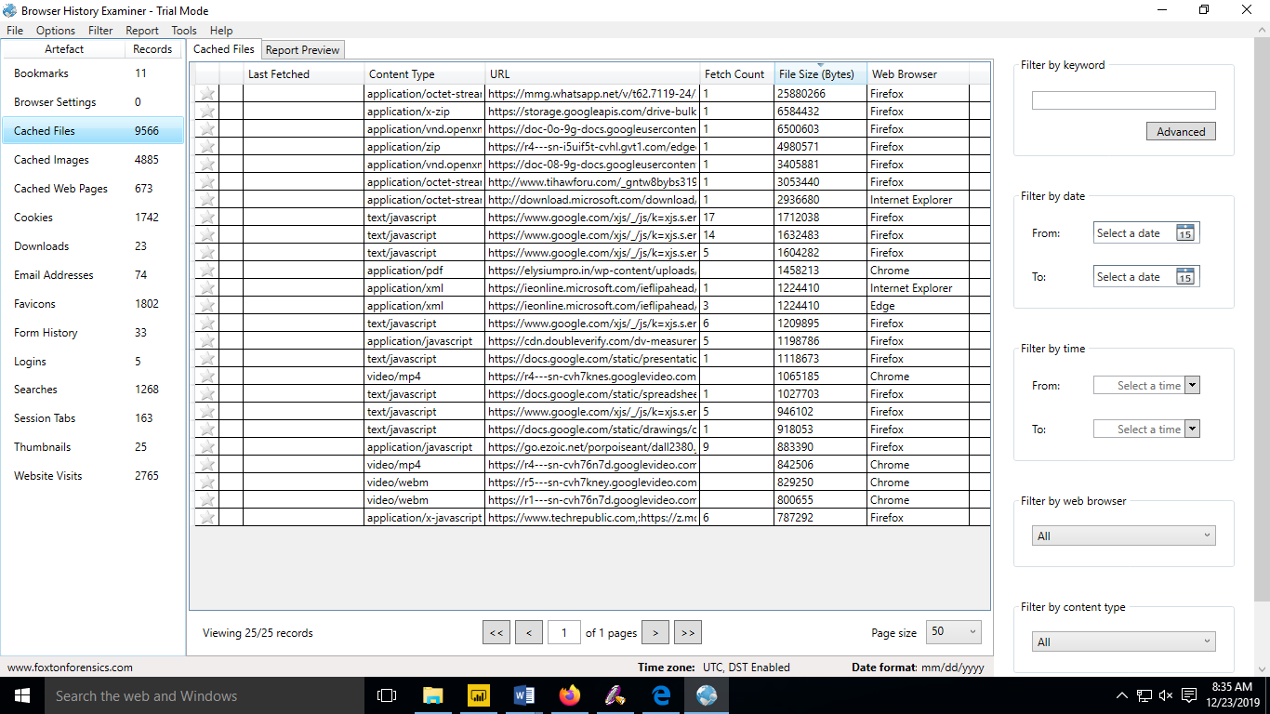

**9. On the left panel click on cached images.**

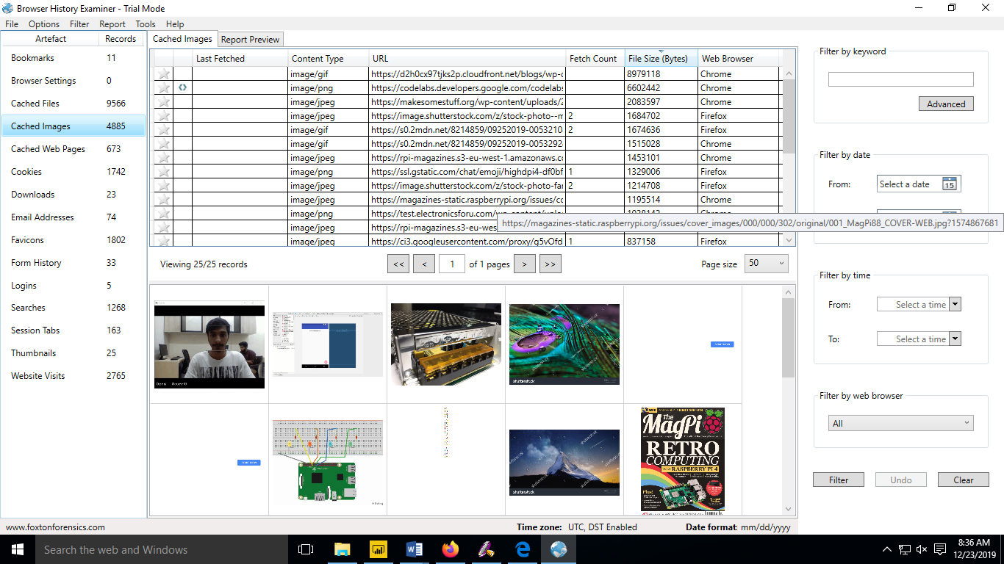

**10. On the left panel click on cookies.**

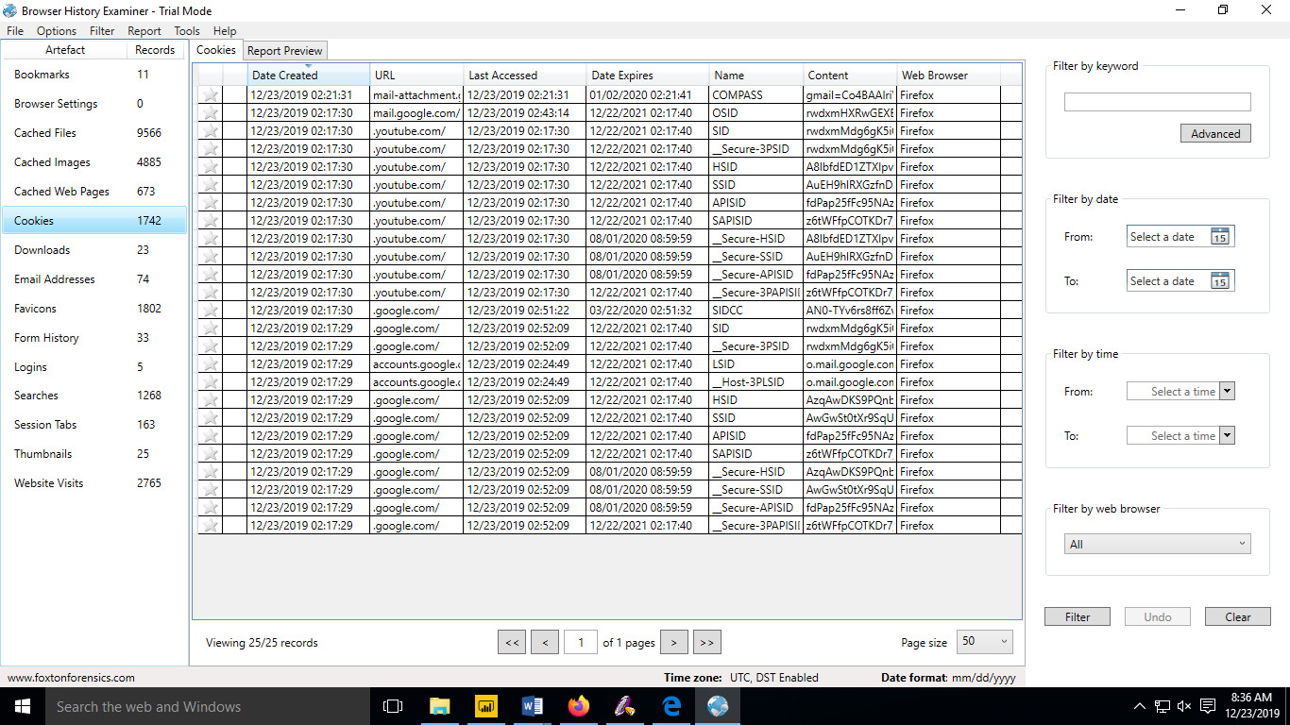

**11. To Create Reports. Click on file > Report and save the report as pdf or html page.**

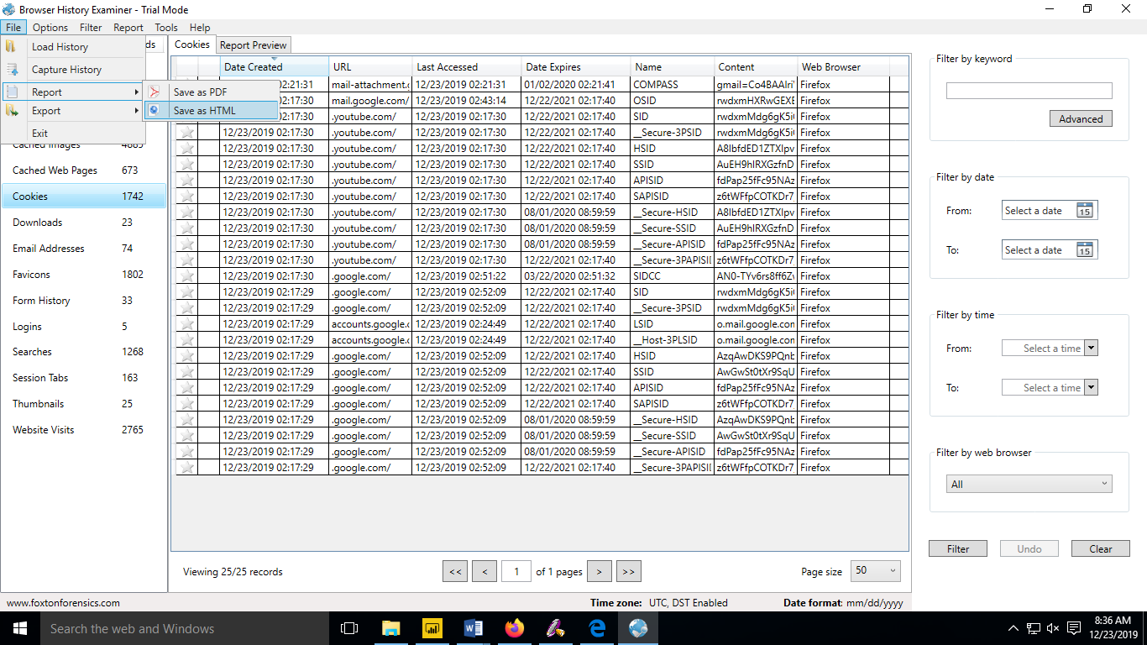

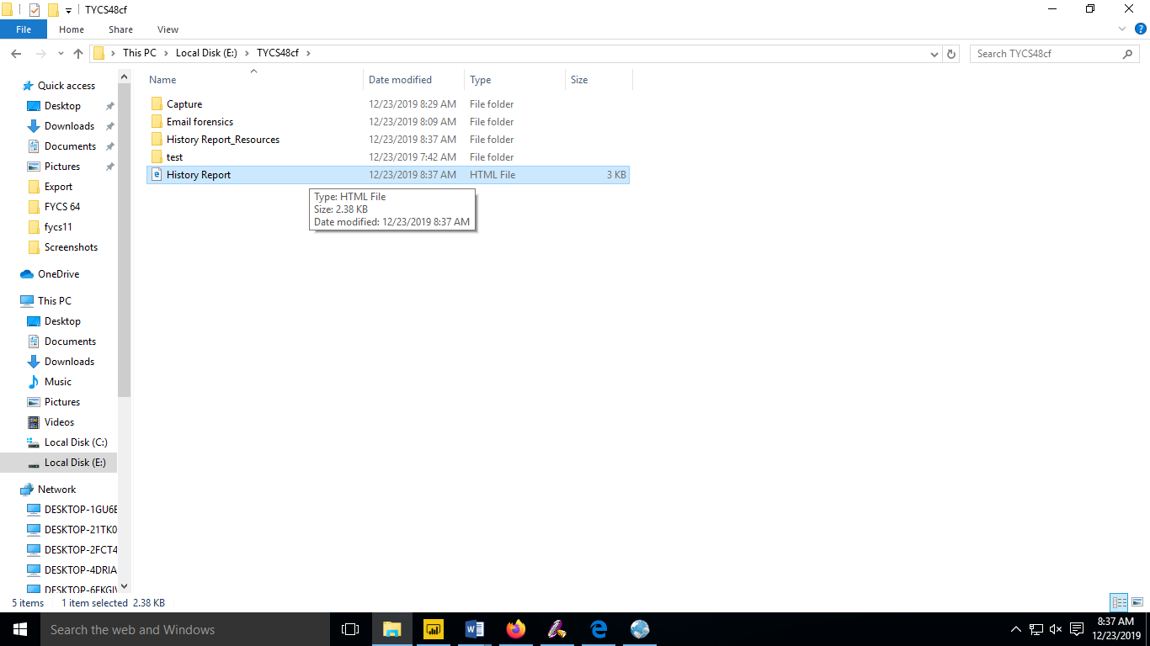

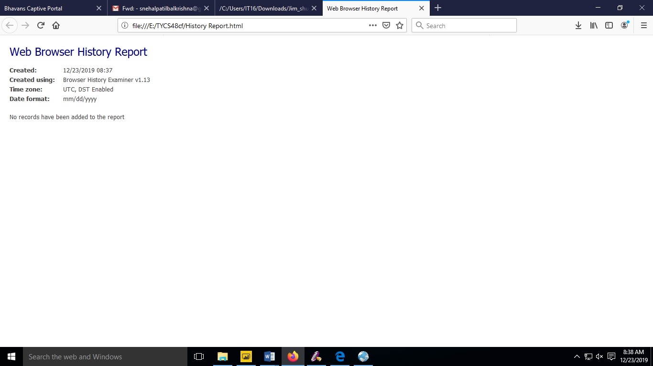

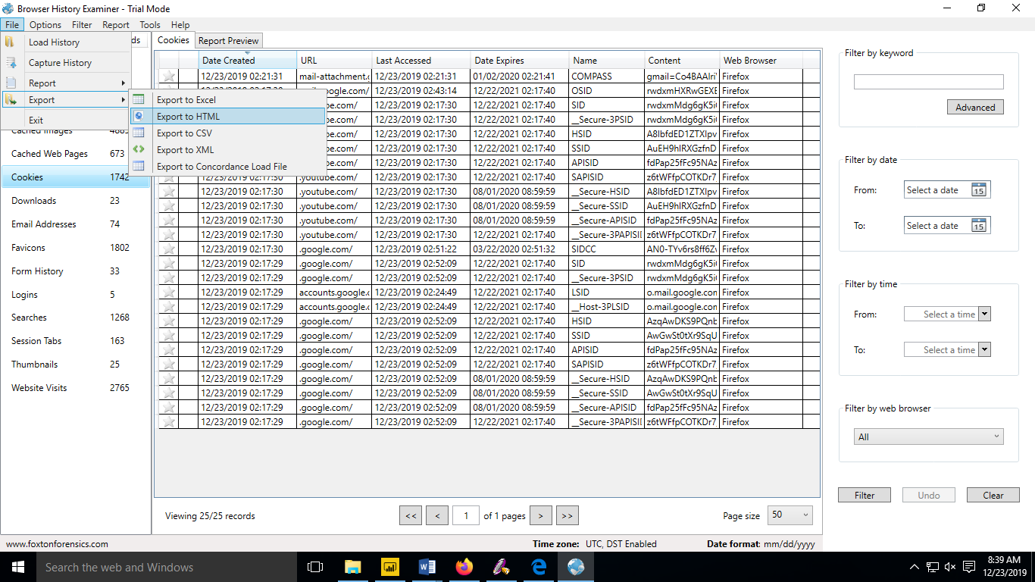

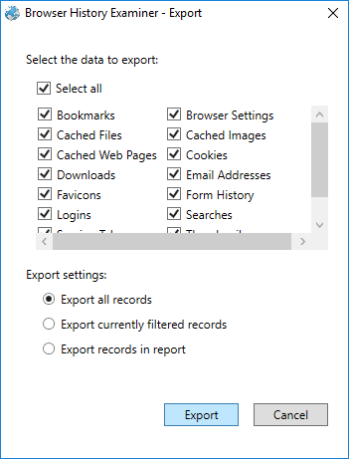

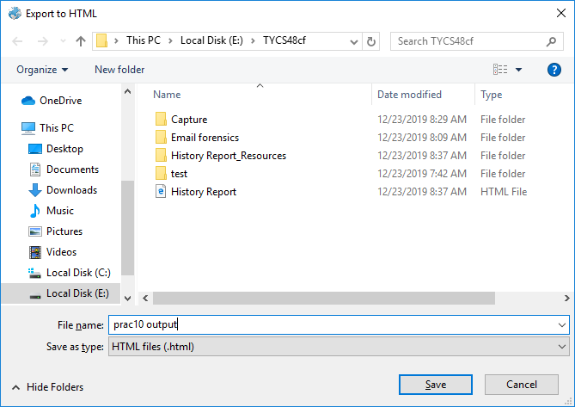

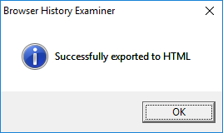

**Output:**

